Extract Clean Order Records

Selects transaction ID, customer ID, order date, and total amount from cleaned transactions. Formats string purchase dates into standard SQL dates (STR_TO_DATE. Filters results to include successful payment statuses only.

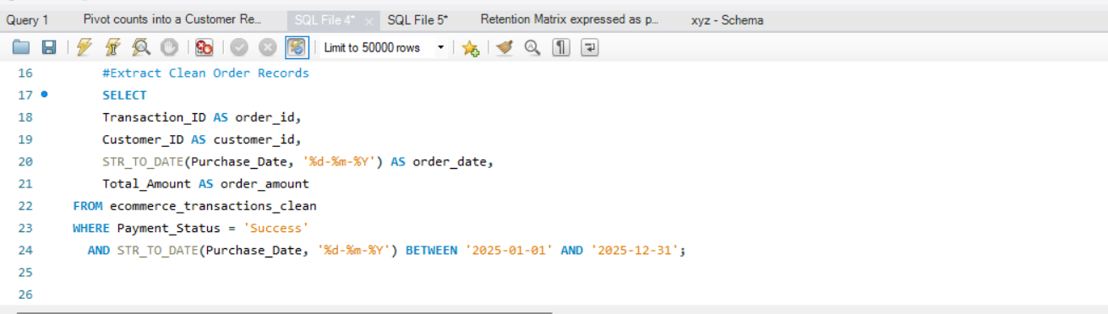
QUERY -;

OUTPUT-;
